***ANUDIP FOUNDATION***

A Project Report on

**ONLINE ART GALLERY**

By

Batch: ANP-C7344

Student ID: AF0368266

Name: Nandini Saka

Student ID: AF0368589

Name: Akanksha Mamdyal

**Under the Guidance of**

Mrs. Rajshri Chandrabhan Thete

ONLINE ART GALLERY

Online Art gallery management system project helps the owner of the art gallery to maintain the details of the artists, paintings, clients, orders, stock etc.

**ENTITIES:**

* Customer
* Order
* Arts
* Order list
* Category

**VARIOUS ENTITIES:**

1. **Customer**

* Customer_id
* Customer_name
* Contact
* Address
* Amount Spent

1. **Order**

* Order_id
* Painting_id
* Customer_id
* Price
* Date
* Phone
* Confirmation

1. **Artists**

* Name
* Birthplace
* Style
* Age
* Artist_id

1. **Order List**

* Title
* Quantity
* Price
* Category_id
* Artist_id

1. **Category**

* Name
* Category_id

**ENTITY RELATIONSHIP DIAGRAM – ONLINE ART GALLARY**

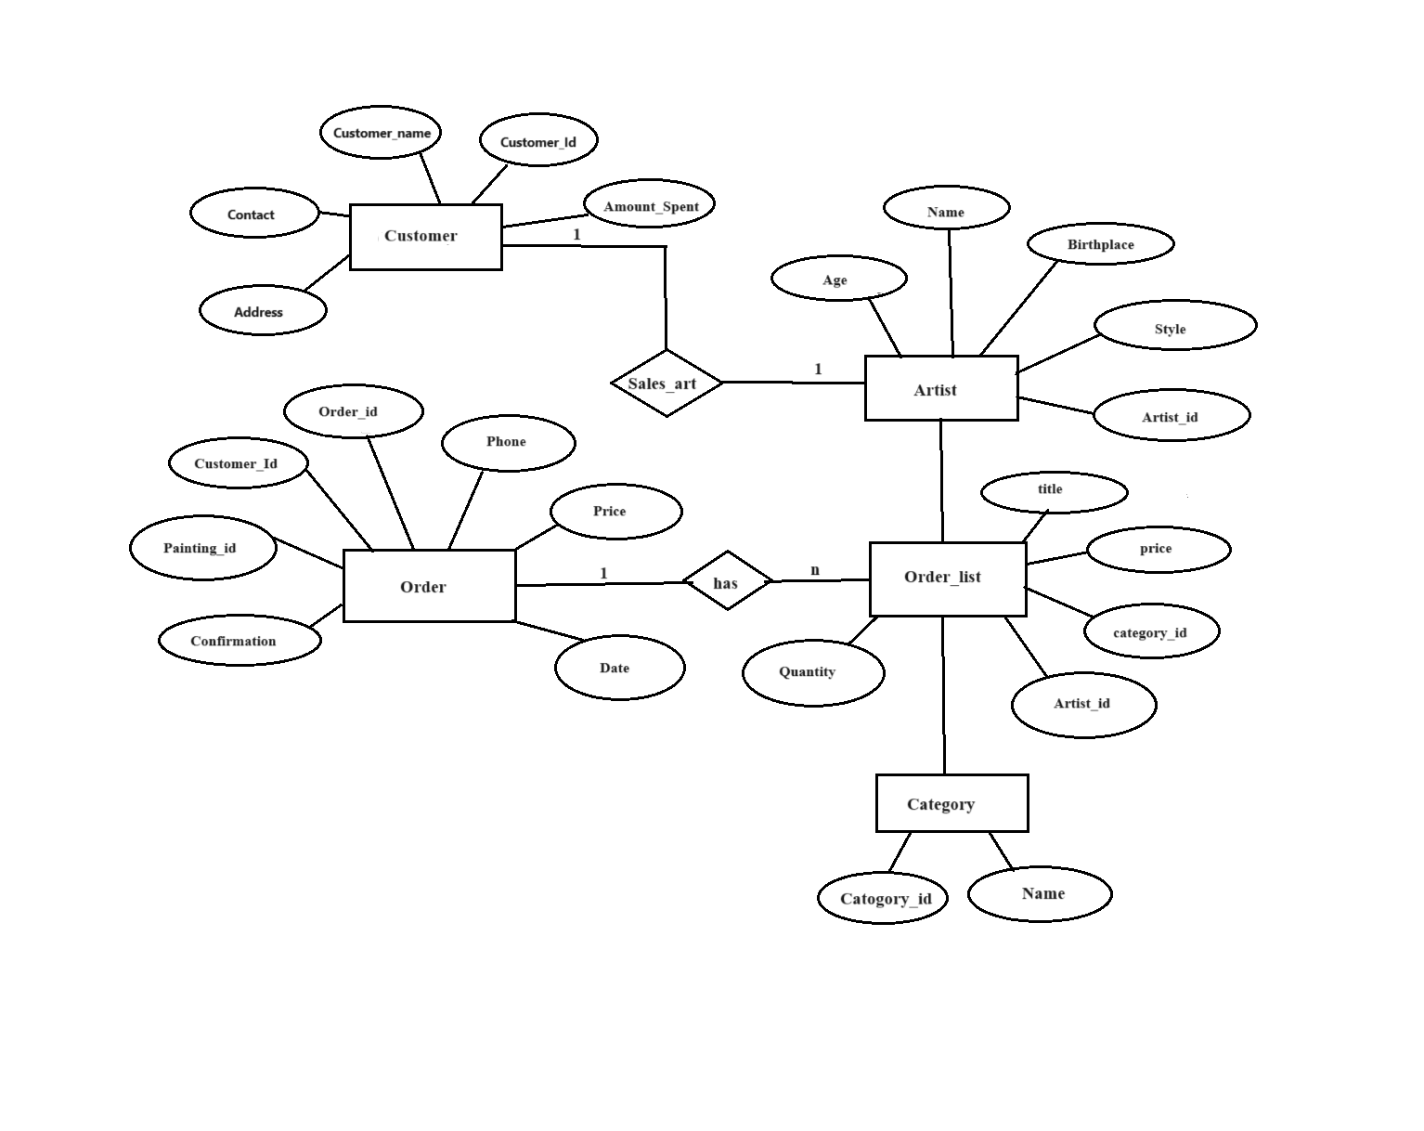

**CLASS DIAGRAM FOR PATIENT MANAGEMENT**

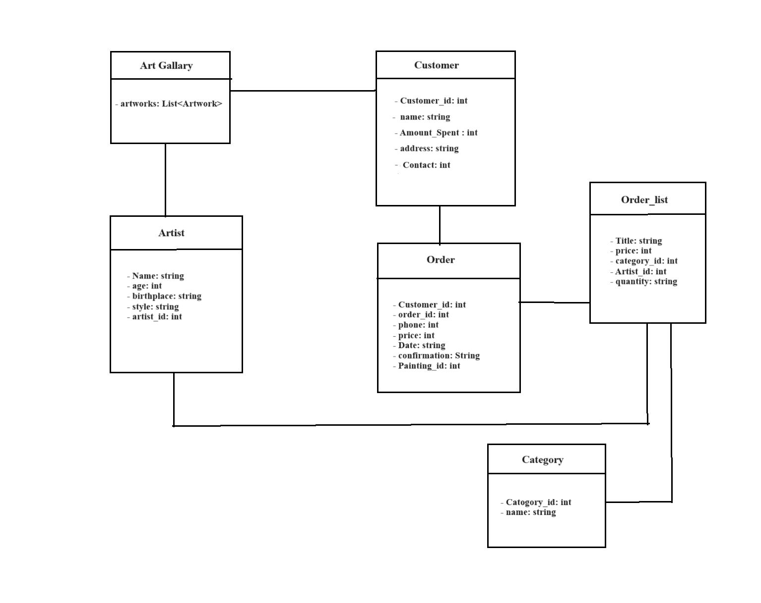

**CONCLUSION**

In conclusion, the emergence of online art galleries marks a transformative chapter in the history of art appreciation. These digital platforms transcend geographical limitations, making art accessible to a global audience. The customer journey map underscores the importance of a seamless, engaging, and personalized experience, while empathy elevates this experience, connecting visitors to the artists and their creative narratives.

As technology continues to evolve, the potential for even more immersive and interactive online art galleries is immense. The fusion of art and technology allows us to redefine how we perceive, understand, and connect with creative expressions. Whether through VR experiences or interactive storytelling, the online art gallery is a testament to human innovation and our enduring relationship with art.